|  |  |  |  |  |
| --- | --- | --- | --- | --- |
|  | |  |  | | --- | --- | |  | **FPT INTERNATIONAL TRAINING INSTITUTE**  **INTERNATIONAL PROGRAMMING FPT - APTECH** | |  |

Center Name: DETECH TOWER- FPT

Address: 8 Ton That Thuyet Street, Ha Noi City, Vietnam.



**E-Greeting**

**Design Document**

|  |  |  |  |
| --- | --- | --- | --- |
| **Faculty:** |  | **Mr. Pham Quang** |  |
| **Batch No:** |  |  |  |
| **Group No.:** |  | **1** |  |
| **Students:** |  | **Fullname** | **Roll No.** |
|  | 1. | Nguyen Tien Thinh | Team lead |
|  | 2. | Pham Thanh Dat | Member |
|  | 3. | Nguyen Manh Tien | Member |
|  | 4. | Nguyen Doan Phi Hung | Member |

**Oct, 2019**

TABLE CONTENTS

REVIEW 1 3

I. Problem Definition 4

1. Introduction: 4

2. Problem definition 4

3. Solution: 4

II. Customer Requirement Specification 5

1. System functions: 5

2. User cases: 5

3. Process schema: 7

- Login process: 7

- Manage process 7

- User process 8

4. Hardware/Software Requirements 9

- Hardware 9

- Software 9

REVIEW 2 10

I. Architecture and Project Design 11

1. Architecture and Project Design 11

2. Database E-R Diagram 12

3. Database Structure 12

REVIEW 3 16

I. Admin site 17

1. Site map 17

- Content management system sitemap (only for admin) 17

2. Roles management page: 17

3. User management page: 18

4. Categories management page: 19

5. Ecards management page: 19

6. Orders management page: 20

7. Feedbacks management page: 20

8. Payments management page: 21

9. Subscribers management page: 21

II. User site 23

1. Site map 23

- User sitemap 23

2. Homepage: 23

3. Ecard details: 24

4. Cart details: 25

5. Payment: 26

6. Login: 27

7. Register: 27

# REVIEW 1

I. Problem Definition

1. Introduction:

* E-Greeting is a website application where a user chooses from an on-line catalog of e-cards made available on the web site. After selecting a card, the sender can personalize it to various degrees by adding a message, photo, or video. Finally, the sender specifies the recipient's e-mail address and the web site delivers an e-mail message on behalf of the sender to the recipient.
* An e-card is similar to a postcard or greeting card; with the primary difference being it is created using digital media instead of paper or other traditional materials

2. Problem definition

* For users no need to write cards or hand-deliver letters. Just select the card and design the card on the website and locate the recipient's e-mail, an e-mail message will be sent to the recipient.

3. Solution:

* The most affordable solution for you to send invitations, greeting cards to your customers and partners. Using e-cards, you do not need to spend on printing and sending.

II. Customer Requirement Specification

1. System functions:

* The site dynamic data is updated by only ADMIN.
* The role of Admin will be adding new templates for various occasions which can be further used by the user.
* User has to register their account first for using the site facility.
* Any Guest user can also subscribe for monthy services offered but it will be chargeable on the monthly basis.
* The constraint validation must be provided to the field to accept the appropriate data type.
* Navigation of the project must be smooth.
* User can also send the feedback.
* All the data must be viewed by the admin.
* Admin can deactivate the status of the user who has subscribed the services of sending the mail.
* Report section must be added for the Admin to view the daily transaction happening from the site.

2. User cases:

|  |  |  |
| --- | --- | --- |
| **Input** | **Process** | **Output** |
| - Admin:   * Update the data of the site * Add and remove template ecards * View feedback from user * View list transaction done (ecard sending and details) * Check payment from user or subscriber. | - Handling on the Database retrieves the necessary data, checking the customer membership registration process | - Display to page: :   * Screen to manage category * Screen to manage ecards * Screen to manage transaction * Screen to manage feedback * Screen to manage payment |
| - User:   * Register account * Select any template ecard to send * Add personal information to send * Become subscriber. | - Login, select any ecard, update and custom order information. | - Process results:   * Log in * Send feedback * Create transaction * Tracking transaction send ecard online. |
| - Subscriber:   * Register account * Select any template ecard to send * Add personal information to send * Become subscriber for daily receiving cards | - Login, update member information, update comment information, add order information. | - Process results::   * Log in * Send comments, feedback * Update personal information * Show comments on the product * Display order information |

3. Process schema:

- Login process:

Login

Error

notification.

Admin

User

Check information

True

False

- Manage process

Manager

User

View

Add

Edit

Block

Database

Category

View

Search

Add, Edit,Delete

Ecard

View

Add

Edit

Delete

Transaction

Order/

OrderDetail

View

Add

Edit

Delete

Manager

Feedback

View

Add

Edit

Block

Database

Payment

View

Search

Add,Edit,Delete

Subscriber

View

Add

Edit

Delete

- User process

User

Database

Order

Ecard

Send ecard

View

Add

View

Add

View

Filter

Search

Tracking order

View

4. Hardware/Software Requirements

- Hardware

* A minimum computer system that will help you access all the tools in the courses is a Pentium 166 or better
* 256 Megabytes of RAM or better
* Windows 2000 (or higher if possible)

- Software

**Either or combination of the following Software’s are to be used:**

* Notepad/Visual code/Visual studio
* Asp.net
* SQL Server 2000
* IE 5.0/ Netscape 6.0
* Visual Studio .Net / ASP
* IIS server
* .Net Framework, Entity framework

# REVIEW 2

I. Architecture and Project Design

1. Architecture and Project Design

## 

2. Database E-R Diagram

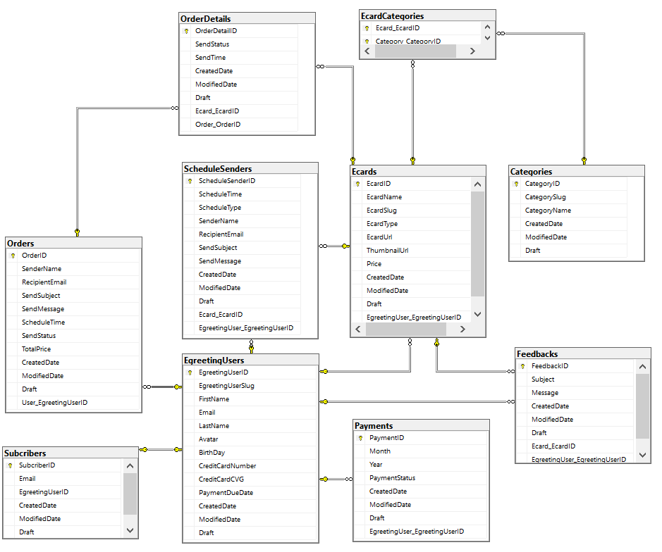

3. Database Structure

|  |  |  |  |  |
| --- | --- | --- | --- | --- |
| **Categories** | | | | |
| **Column Name** | **Data Type** | **Allow Null** | **Key** | **Description** |
| CategoryID | int | No | Privery Key |  |
| CategorySlug | nvarchar(100) | Yes |  |  |
| CategoryName | nvarchar(100) | Yes |  |  |
| Draft | bool | No |  | True is the record is deleted |
| CreatedDate | datetime | Yes |  | Created time |
| ModifiedDate | datetime | Yes |  | Modified time |

|  |  |  |  |  |
| --- | --- | --- | --- | --- |
| **Ecard_Categorys** | | | | |
| **Column Name** | **Data Type** | **Allow Null** | **Key** | **Description** |
| EcardID | int | No | Primery Key |  |
| CategoryID | int | No | Foreign key | Link to category table |

|  |  |  |  |  |
| --- | --- | --- | --- | --- |
| **EgreetingRoles** | | | | |
| **Column Name** | **Data Type** | **Allow Null** | **Key** | **Description** |
| EgreetingRoleID | Int | No | Primery Key |  |
| EgreetingRoleName | nvarchar(100) | Yes |  |  |
| Draft | bool | No |  | True is the record is deleted |
| CreatedDate | datetime | Yes |  | Created time |
| ModifiedDate | datetime | Yes |  | Modified time |

|  |  |  |  |  |
| --- | --- | --- | --- | --- |
| **Ecards** | | | | |
| **Column Name** | **Data Type** | **Allow Null** | **Key** | **Description** |
| EcardID | int | No | Primery Key | Key of ecard |
| EcardSlug | nvarchar(100) | Yes |  | Slug of ecard is unique |
| EcardType | int | No |  | 1: Picture, 2: Gif, 3: Text, 4: Video |
| EcardUrl | nvarchar(500) | Yes |  | Name save in server and database |
| ThumbnailUrl | nvarchar(100) | No |  | Save thumbnail for ecard |
| Price | Double | No |  | Price for send the ecard |
| Draft | Bool | No |  | True is the record is deleted |
| Sreatedate | Datetime | Yes |  | Created time |
| ModifiedDate | datetime | Yes |  | Modified time |
| CategoryID | Int | Yes | Foreign key | Link to category |
| EgreetingUserID | int | Yes | Foreign key | Link to user |

|  |  |  |  |  |
| --- | --- | --- | --- | --- |
| **Feedbacks** | | | | |
| **Column Name** | **Data Type** | **Allow Null** | **Key** | **Description** |
| FeedbackID | int | No | Primery Key |  |
| Subject | nvarchar(100) | Yes |  | Subject text of feedback |
| Content | nvarchar(1000) | Yes |  | Content of feedback |
| Draft | bool | No |  | True is the record is deleted |
| CreatedDate | datetime | Yes |  | Created time |
| ModifiedDate | datetime | Yes |  | Modified time |
| EcardID | int | Yes |  | Foreign key link to Ecard table |
| EgreetingUserID | int | Yes |  | Foreign key link to EcardUser table |

|  |  |  |  |  |
| --- | --- | --- | --- | --- |
| **EgreetingUsers** | | | | |
| **Column Name** | **Data Type** | **Allow Null** | **Key** | **Description** |
| EgreetingUserID | int | No | Primery Key |  |
| EgreetingUserSlug | nvarchar(100) | Yes |  | Slug of user page link |
| FirstName | nvarchar(50) | Yes |  |  |
| LastName | nvarchar(100) | Yes |  |  |
| BirthDay | datetime | Yes |  |  |
| CreditCardNumber | nvarchar(12) | Yes |  |  |
| CreditCardCVG | nvarchar(3) | Yes |  | Password to paid for bild |
| PaymentDueDate | datetime | Yes |  |  |
| Draft | bool | No |  | Status |
| CreatedDate | datetime | Yes |  | Created time |
| ModifiedDate | datetime | Yes |  | Modified time |
| EgreetingRoleID | int | No |  |  |
| SubscriberID | int | No |  | Mã của người đăng ký |
| Avatar | varbinary(MAX) | No |  | Hình đại diện |

|  |  |  |  |  |
| --- | --- | --- | --- | --- |
| **OrderDetails** | | | | |
| **Column Name** | **Data Type** | **Allow Null** | **Key** | **Description** |
| OrderDetailID | int | No | Primery Key | Mã đơn hàng chi tiết |
| ScheduleTime | datetime | Yes |  | Lịch trình |
| SendStatus | bool | No |  | Status gửi |
| SendTime | datetime | No |  | Thời gian gửi |
| Price | Double | No |  | Giá bán |
| Draft | bool | No |  | Status |
| CreatedDate | datetime | Yes |  | Created time |
| ModifiedDate | datetime | Yes |  | Modified time |
| EcardID | int | Yes |  | Mã của thẻ |

|  |  |  |  |  |
| --- | --- | --- | --- | --- |
| **Orders** | | | | |
| **Column Name** | **Data Type** | **Allow Null** | **Key** | **Description** |
| OrderID | int | No | Primery Key | Mã đặt hàng |
| SenderName | nvarchar(100) | No |  | Tên người gửi |
| RecipientEmail | nvarchar(100) | No |  | Người nhận E-mail |
| SendSubject | nvarchar(100) | Yes |  | Chủ đề gửi |
| SendMessage | nvarchar(500) | Yes |  | Gửi tin nhắn |
| SendStatus | bool | No |  | Status gửi |
| TotalPrice | Double | No |  | Tổng giá |
| Draft | bool | No |  | Status |
| CreatedDate | datetime | Yes |  | Created time |
| ModifiedDate | datetime | Yes |  | Modified time |
| EcardID | int | Yes |  | Mã của thẻ |

|  |  |  |  |  |
| --- | --- | --- | --- | --- |
| **Subscribers** | | | | |
| **Column Name** | **Data Type** | **Allow Null** | **Key** | **Description** |
| SubscriberID | int | No | Primery Key | Mã của người đăng ký |
| SubscriberEmail | nvarchar(100) | Yes |  | Email của người đăng ký |
| CreatedDate | datetime | Yes |  | Ngày tạo |
| ModifiedDate | datetime | Yes |  | Modified time |
| EgreetingUserID | int | No |  | Mã của người dùng lời chào điện tử |

|  |  |  |  |  |
| --- | --- | --- | --- | --- |
| **Payments** | | | | |
| **Column Name** | **Data Type** | **Allow Null** | **Key** | **Description** |
| PaymentID | int | No | Primery Key |  |
| Month | float | No |  |  |
| Year | bit | No |  |  |
| Email | nvarchar(100) | No |  |  |
| PaymentStatus | bool | No |  |  |
| CreatedDate | datetime | Yes |  | Created time |
| ModifiedDate | datetime | Yes |  | Modified time |
| EgreetingUserID | int | Yes | Foreign key |  |

# 

# REVIEW 3

I. Admin site

1. Site map

- Content management system sitemap (only for admin)

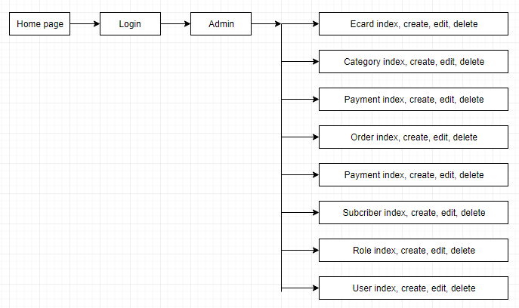

2. Roles management page:

## 

## Objective: Show, edit and delete roles (admin, user, subscriber);

## Description: This is a dynamic page, retrieving data from the role table

3. User management page:

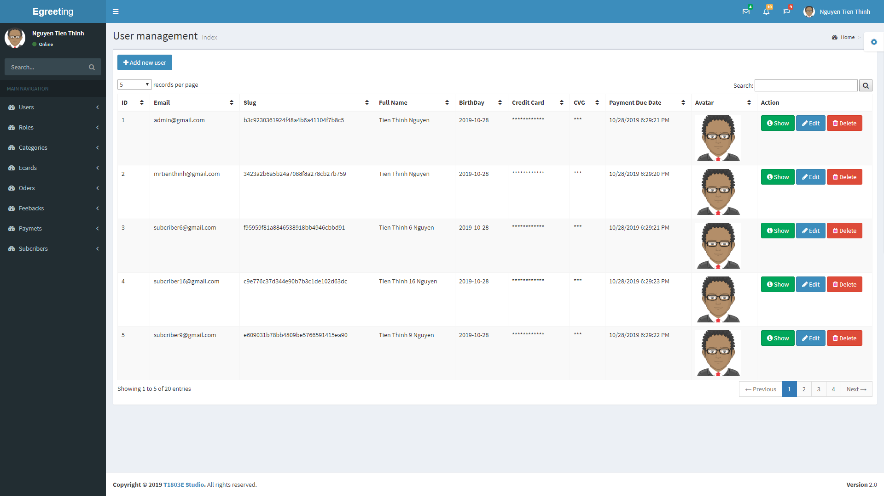

## Objective: Show, edit and delete user;

## Description: This is a dynamic page, retrieving data from the EgreetingUser table

4. Categories management page:

## 

## Objective: Show, edit and delete categories;

## Description: This is a dynamic page, retrieving data from the Categories table

5. Ecards management page:

## 

## Objective: Show, edit and delete ecards;

## Description: This is a dynamic page, retrieving data from the Ecards table

6. Orders management page:

## 

## Objective: Show, edit and delete order, send email for that orders;

## Description: This is a dynamic page, retrieving data from the Orders and OrderDetails table

7. Feedbacks management page:

## 

## Objective: Show, edit and delete feedback;

## Description: This is a dynamic page, retrieving data from the Feedback;

8. Payments management page:

## 

## Objective: Show, edit and delete feedback;

## Description: This is a dynamic page, retrieving data from the Feedback;

9. Subscribers management page:

## 

## Objective: Show, edit and delete subscriber;

## Description: This is a dynamic page, retrieving data from the Subscriber;

## 

II. User site

1. Site map

- User sitemap

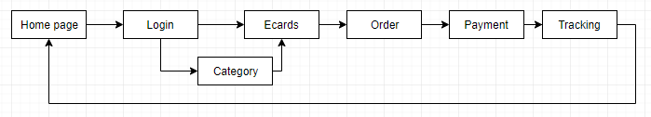

2. Homepage:

## 

## 

## Objective: Show all ecard, search and filter, select ecard then add to cart;

## Description: Header is the same with every page, section top ecard, display hottest ecard from website, section show ecard to directly add to cart or link to detail page, footer of page is the same in every page;

3. Ecard details:

## Objective: Show more detail and send feedback for paticular ecard;

## Description: Main section show more information of ecard than home page. The main page only show thumbnail of ecards, so the details page show the real ecard content.;

4. Cart details:

## 

## Objective: Check the select ecard and fill more content to send ecard to a specific email;

## Description: Show list ecard that customer had been added to cart. Customer can’t remove any ecard from cart. Next process will get payment for this cart;

5. Payment:

## 

## Objective: Check the select ecard and fill more content to send ecard to a specific email;

## Description: Show list ecard that customer had been added to cart. Customer can’t remove any ecard from cart. Next process will get payment for this cart;

6. Login:

## Objective: Login page;

## Description: Show form for login;

7. Register:

## Objective: Register page;

## Description: Show form for register;